Inventory –Transfer Bookings

Transferring bookings/panel reservations from the panel picker.

Click on menu option Charting – Open Campaign.
Select the contract number using; the quick campaign search icon.
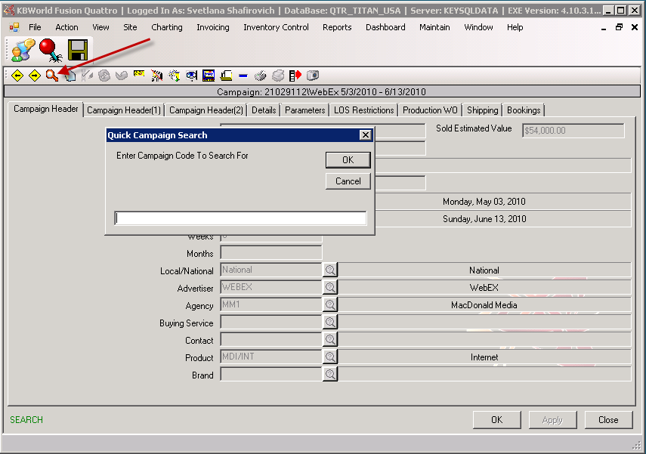
You can also use the advanced search from the file menu. Go to Action – Find.
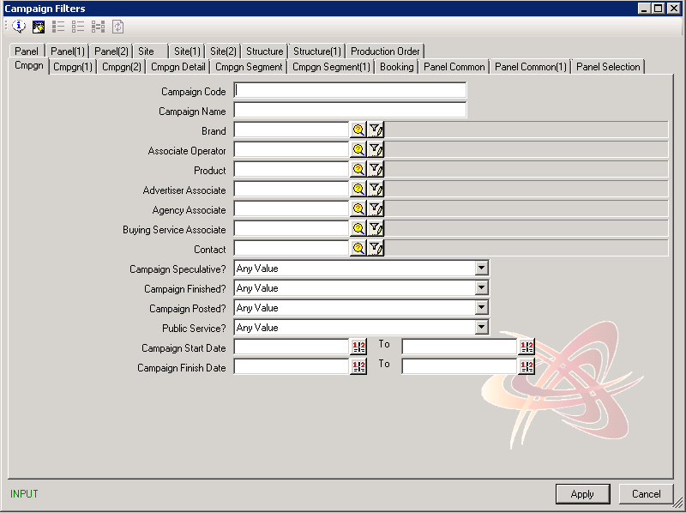

Once you’ve selected the contract and segment, click on Schedule button to go to the panel picker for that segment
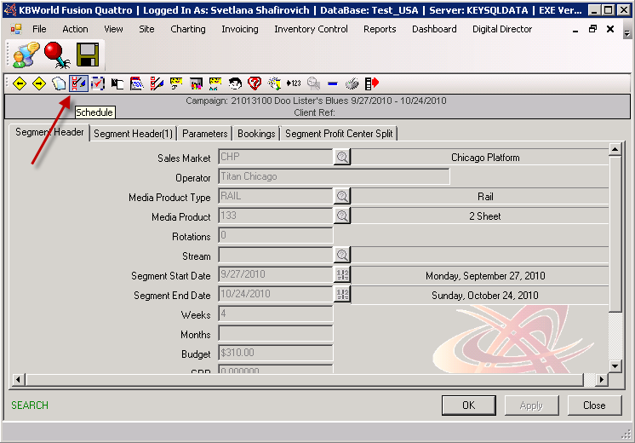
From the panel picker, click Transfer Booking
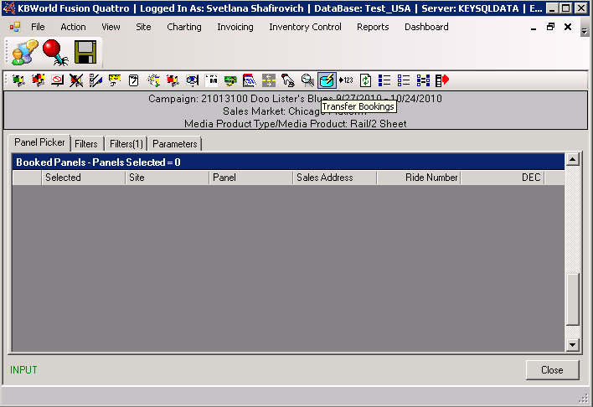

Transfer Bookings

In the transfer bookings window, the top section will have details of the contract you’re transferring to. In the bottom section enter the contract you want to transfer from (you can use the magnifying glass to find a contract if your not sure what the contract number is).

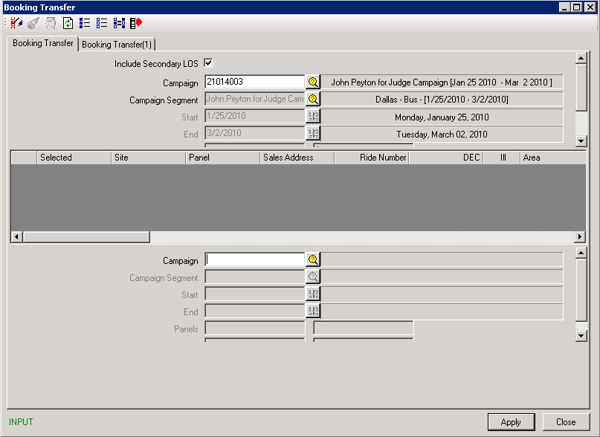

Once the contract has been entered, select a segment and panels on the Bookings Transfer Tab. To complete the transfer click the Transfer Selected Panels
